**Code of Conduct**

The following rules concern every single Group H member. All are effective immediately upon signing.

1. All team members must be treated with respect and practice solidarity within the group.
2. Every team member’s opinion must be thoroughly considered.
3. If one team member disagrees with another, this must be discussed in a civilized manner.
4. All team members must allow one another to voice their opinion without being interrupted and/or talked down on.
5. Do not be over 10-15 minutes late or absent from group meetings without warning.
6. Plagiarism of any sort is not tolerated.
7. When reviewing another team member’s work, it is necessary to provide constructive criticism when necessary.
8. All group members must contribute an equally proportionate amount of work and effort towards the group’s tasks.
9. Read and respond to group messages. This rule essentially means every member must be somewhat active in between workdays and hours. (Monday – Friday, 9AM – 5-6PM).
10. Behavior that disrupts team meetings is strictly prohibited; personal matters must be kept out of them.
11. All decisions relating to the group’s work must be decided democratically.
12. Once finished with your work, it is mandatory to assist fellow group members.
13. Degrading / highly offensive comments directed towards other group members is strictly prohibited.
14. All group members should speak in English so that everyone can understand what is being said. It is to be stated that there are certain exceptions to this rule for the sake of clarity.
15. It is necessary to voice your opinion regarding group decisions, as these decisions will be final.
16. Do not be late or absent from important meetings.
17. All group work must remain within the group and not be shared/leaked to an outside source/other group.
18. Rules and roles are subject to change for any reason as long as 75% of the group agrees.
19. All group members must respect the appropriate deadlines for their work.
20. Each member of the group is required to complete a qualitative task, and the assessment of the work's quality will be conducted by fellow group members.
21. If there is a meeting planned inform the group members 1 day prior to the meeting.

All strikes will be deliberated upon by the entire group to determine their necessity.

In the case of a strike's approval, a discussion will ensue with the group members involved. If the member is unable to resolve the issue leading to the strike, the matter will be communicated to the group's mentor for appropriate discussion and resolution.

At the third strike, the team will communicate with Miguel to request a kick-out for the person who got the strike.

Team Leader: Mihail Josan – 5305624

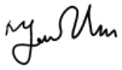

Co-leader: Ofelia Hănțoiu - 5280737



Secretary: Thư Trần - 5274842

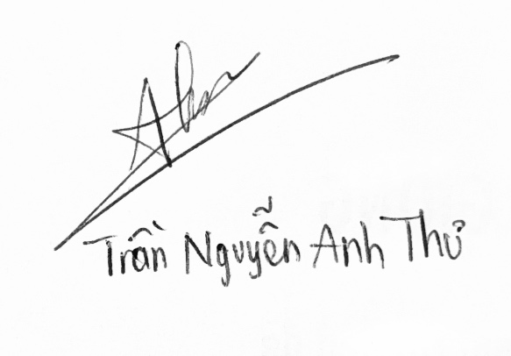

Quality Control: Cristian Trifan

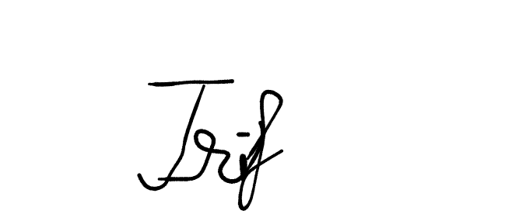

Quality Control: Yến Phan – 5329957

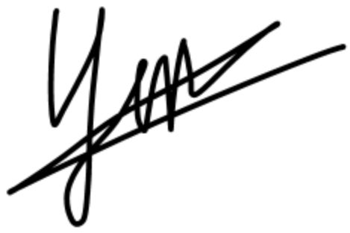

Developer: Patrick Beligeanu – 5125251

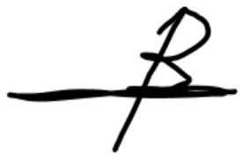

Developer: Joris Backis - 5419980